RDVLF-40Y Very Low Frequency HV Test Set
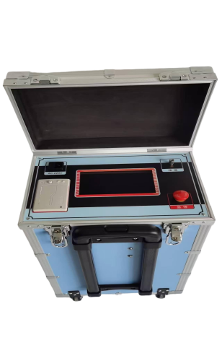
The withstand voltage test is divided into two categories: AC and DC. The AC withstand voltage includes technologies such as power frequency, variable frequency, and 0.1Hz ultra-low frequency. As the latest testing solution recommended by the International Electrotechnical Commission (IEC), the 0.1Hz ultra-low frequency technology has significant technical advantages.
Our new-generation ultra-low frequency high-voltage generator is independently developed with cutting-edge American technology, equipped with a 7-inch touch screen, ARM7 single-chip microcomputer, high-speed AD acquisition circuit, and supporting background management software. This product overcomes the defects of similar domestic equipment, with a cost-performance ratio superior to imported products. It is particularly suitable for withstand voltage testing of electrical equipment with large insulation equivalent capacitance, such as power cables, capacitors, large and medium-sized generators, and motors.
- Product features
- Advanced Technology: Utilizes digital frequency conversion technology and microcomputer control for fully automated testing processes, including voltage boosting, voltage reduction, measurement, and protection.
- User-Friendly Operation: Features simple wiring and intuitive controls for easy setup and operation.
- Comprehensive Protection: Equipped with multiple safeguards (overvoltage protection, high/low voltage side overcurrent protection) with rapid response times (≤10ms) to ensure instrument safety and reliability.
- Safety-Assured Design: The controller and high-voltage generator are connected via low-voltage optical control, ensuring safe and reliable operation.
- Stable Output: Incorporates high/low voltage closed-loop negative feedback control circuits to eliminate capacitive voltage rise effects.
- Complete Configuration: Includes a capacitive touchscreen, LCD Chinese display, automatic data storage, and built-in printing capabilities.
- Wide Testing Range: Offers multi-frequency options (0.1Hz, 0.05Hz, and 0.02Hz) for versatile testing applications.
- Portable Design: Compact size and lightweight construction facilitate easy transportation and outdoor operations.
- Product specifications and technical parameters
- Rated output voltage and load capacity
Rated output voltage | Load capacity at different frequencies | Power supply fuse | Product Structure and Weight
40kV (peak value) | 0.1Hz, ≤1.1µF | 10A | Integrated type: 35KG
40kV (peak value) | 0.05Hz, ≤2.2µF | 10A | Integrated type: 35KG
40kV (peak value) | 0.02Hz, ≤5.5µF | 10A | Integrated type: 35KG
- Rated Output Voltage: 40kV
- Output Frequency: 0.1Hz, 0.05Hz, 0.02Hz
- Load Capacity:
① Maximum 1.1µF at 0.1Hz
② Maximum 2.2µF at 0.05Hz
③ Maximum 5.5µF at 0.02Hz
- Measurement Accuracy: 3%
- Voltage Peak Error (Positive/Negative): ≤3%
- Voltage Waveform Distortion: ≤5%
- Operating Conditions: Indoor/Outdoor; Temperature: -10°C to +40°C; Humidity: ≤85%RH
- Power Supply: 220V±5%, 50±5Hz

